2014 Pew Research Center’s American Trends Panel

Wave 4

Methodology Report

Submitted to:
The Pew Research Center
1615 L Street, NW
Suite 700
Washington, DC 20036

Prepared by:
Abt SRBI
Courtney Kennedy
Marci Schalk
Nick Bertoni
Chintan Turakhia
Dean Williams
275 Seventh Avenue, Suite 2700,
New York, New York 10001
(212) 779-7700
www.srbi.com

July 8, 2014

I. SUMMARY
The American Trends Panel (ATP) is a national, probability-based online panel of adults in the United States living in households. Adults who use the internet participate in the panel via self-administered Web surveys, and adults who do not use the internet participate via computer assisted telephone interviewing (CATI) or mail. The fourth wave of the panel survey was fielded for the Pew Research Center by Abt SRBI from May 30 through June 30, 2014. The survey was administered in English and Spanish. In total, 3,217 ATP members completed the survey, with 2,849 participating by Web and 368 participating by mail. The responding sample is weighted to account for differential probabilities of selection into the panel as well as differential nonresponse to the recruitment survey, the panel invitation, and the panel survey itself. The margin of sampling error for full sample weighted estimates is ±2.23 percentage points.

II. SAMPLE DESIGN
The target population for the Wave 4 Survey was non-institutionalized persons age 18 and over, living in the US. The sample consisted of 5,285 members of the ATP, which is a probability-based online panel of adults in the United States. The ATP originally consisted of 5,338 members, however, 53 members requested to be removed from the panel prior to the start of Wave 4. The Wave 4 Survey featured a simultaneous mixed-mode design. Panelists who use the internet and provided an email address participated via self-administered Web survey, and adults who do not use the internet (or do but did not provide an email address) participated via a mail survey.

III. QUESTIONNAIRE DEVELOPMENT AND TESTING
The questionnaire was developed by the Pew Research Center in consultation with Abt SRBI. In order to improve the quality of the data, the Web program was rigorously tested by Abt SRBI project management team and PRC researchers. Test scenarios were created for all possible combinations of sample variables and question filters to ensure all skip logic was functioning correctly. Test data was then analyzed to determine that all logic was correct.

IV. DATA COLLECTION PROTOCOL FOR THE WAVE 4 STUDY
Currently all ATP panelists have been recruited from a large (n=10,013) national overlapping dual frame landline and cell phone random digit dial (RDD) survey conducted for the Pew Research Center. At the end of that RDD survey, respondents were invited to join the panel. The invitation was extended to all respondents who use the internet (from any location) and a random subsample of respondents who do not use the internet. The RDD survey was conducted from January 23rd to March 16th, 2014, in English and Spanish.

ATP panelists who reported using the internet and for whom we had an email address were invited to participate in Wave 4 via a self-administered Web survey. The data collection for the Web surveys was conducted from June 9 through June 30, 2014. One hundred panelists were included in a soft launch of the Web survey which began with an initial email invitation. The Web panelists chosen for the soft launch were the first 100 cases listed in the sample file when sorted from smallest to largest by key number. The remaining panelists assigned to the Web mode were included in the full launch. In the full launch, advance postcards were mailed to all web mode panelists with a known residential address. Initial email invitations were sent to all web mode panelists, with up to four reminder emails sent to those who did not respond to the Web survey. Table 1 shows the field dates of mailings.

Table 1. Mailing Dates for Wave 4 Panelists in Web Mode
 | Soft Launch | Full Launch
Advance Postcard | --- | June 9, 2014
Initial email invitation | June 9, 2014 | June 10, 2014
1st reminder email | June 12, 2014 | June 13, 2014
2nd reminder email | June 17, 2014 | June 18, 2014
3rd reminder email | June 23, 2014 | June 24, 2014
Final reminder email | June 26, 2014 | June 27, 2014

ATP panelists age 18 to 25 and those who reported being Hispanic/Latino in the RDD recruitment survey were offered a $10 post-paid incentive for completing the Wave 4 Web survey. All other panelists who completed the Web survey were offered a $5 post-paid incentive. Web respondents could choose to receive the post-paid incentive in form of a check or a gift code to Amazon.com. The differential incentive amounts were designed to increase panel survey participation among groups that traditionally have low survey response propensities.

At the start of the Wave 4 Survey, 555 ATP members belonged to the non-Internet arm of the panel. These panelists had provided a residential address during the RDD recruitment survey, but they did not provide an email address. The data collection for both English and Spanish language mail surveys was conducted May 30 through June 23, 2014 following the timeline shown in Table 2. English language surveys were mailed using first class mail and Spanish language surveys were mailed using Priority mail. ATP panelists age 18 to 25 and those who reported being Hispanic/Latino in the RDD recruitment survey received a $10 bill in the first mailing, while all other panelists received a $5 bill. The reminder postcard was sent to all mail mode respondents; however, the second packet was not sent to early non-responders since their initial survey packets were already received. The cutoff date to process returned mail surveys was June 23, 2014, which allowed a week for final data entry and quality checking.

Table 2. Mailing Dates for Wave 4 Panelists in Mail Mode
 | Mail Survey
First Packet | May 30, 2014
Reminder Post Card | June 2, 2014
Second Packet | June 13, 2014

V. WEIGHTING
Survey weights are needed to support reliable inference from the panel to the target population of US adults. The final survey dataset contains a full sample weight (WEIGHT_W4). The design of the full sample weight is described below.

The final full sample weights are computed in three main stages:
- Base weight adjusting for differential probabilities of selection
- Propensity adjustment for nonresponse to the panel invitation
- Calibration to demographic distributions for the target population

Base Weight
A base weight is computed for all ATP members. The base weight adjusts for factors affecting the probability that the individual was selected for the panel. This probability comes from the survey in which the respondent was recruited. Currently, all ATP members were recruited through a probability-based, national overlapping dual frame landline and cell phone RDD survey. The target population for the RDD survey was identical to the target population for the ATP (adults living in households in the US). The RDD survey was administered in English and Spanish. All respondents to the RDD survey were invited to join the panel, except some individuals who do not use the internet, as this group was subsampled for the panel. In the landline sample of the RDD survey, one adult was randomly selected from within the household. Interviewers asked to speak with either the youngest male or youngest female at home at the time of the call. In the cell sample of the RDD survey, interviews were conducted with the person who answered the phone, provided they were age 18+ and spoke English or Spanish.

The base weight was computed using single frame estimation to adjust for the probability that the respondent’s phone number was selected from the sampling frame, the overlap in the landline and cell phone frames, and the within household selection in the landline sample. For most panel members, the base weight is equal to the variable NEWWT1 in the 2014 Pew Research Center Polarization Study dataset and can be expressed as:

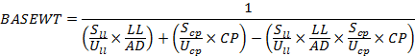
Where:
LL =1 if respondent has a landline phone
=0 if respondent has no landline phone
(OR number of landlines on which the respondent could have been reached)

CP =1 if respondent has a cell phone
=0 if respondent has no cell phone
(OR number of cell phones on which the respondent could have been reached)

S_{ll}= number of cases released in the landline sample

S_{cp}=number of cases released in the cell phone sample

U_{ll}=size of the landline RDD frame

U_{cp}=size of the cell phone RDD frame

AD=number of adults in the household (1, 2, 3 or more)

For a subset of the ATP members, an additional adjustment is included in the base weight to account for the fact that they belong to a group that was subsampled for invitation to the panel. In the RDD survey, non-internet users were subsampled at a rate of 25% from January 23, 2014, through February 5, 2014, but they were not subsampled (100% invited) from February 6, 2014 through the end of the field period. Internet users who agreed to join the panel but did not have an email address were taken at 100% from January 23, 2014, through February 5, 2014, but they were subsampled at a rate of 25% from February 6, 2014, through the end of the field period. The base weight of the affected cases was multiplied by the inverse of the subsampling rate (1 / .25 = 4).

Adjusting for Nonresponse to the Panel Invitation
The panel invitation featured a $10 post-paid incentive for agreeing to join and a fixed post-paid incentive for each panel survey completed. Hispanics/Latinos and adults age 18 to 25 were offered $10 per panel survey, and all other invitees were offered $5 per survey. The differential incentives were designed to preemptively offset anticipated differential response rates across these groups. In total, 9,810 RDD survey respondents were invited to join the ATP and 5,338 accepted, yielding a panel acceptance rate of 54.4%. To the extent that those joining the panel may be different from those not joining, there is a risk that estimates from the panel could be subject to nonresponse bias. A propensity score adjustment was computed to adjust for differential nonresponse to the panel invitation.

A logistic regression model was estimated in which accepting the panel invitation was regressed on sampling frame, incentive amount ($10/$5 per survey), internet user, race, marital status, child in the household, age, education, religious service attendance, household income, frequency of voting, opinion of the Tea Party (agree/disagree), whether or not they contacted an elected official in the last two years, political ideology, and statistically significant 2-way interactions (p<.05). Hispanic ethnicity was excluded from the model because it was collinear with the incentive variable. Gender and the number of adults in the household were not predictive and excluded from the model. The set of predictors considered for the model are variables that are routinely measured in surveys conducted for the Pew Research Center for the People & the Press. The significant predictors used in the final model are presented in Table 3.

The estimated propensities were used to divide cases into approximately equal size groups using the quintiles of the estimated propensity score. Quintiles have been found to be effective in capturing most of the variation. The propensity score adjustment was computed as the inverse of the response rate in each quintile. This approach helps to protect against model misspecification, relative to using the inverse of the response propensities.

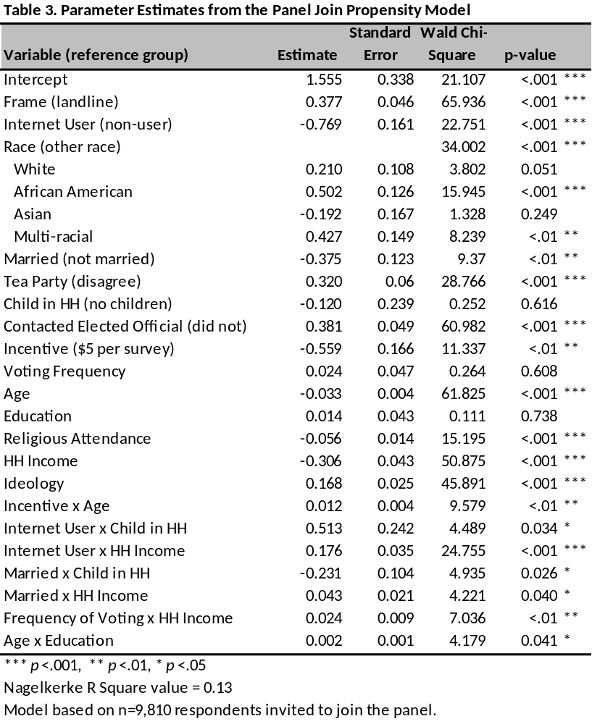
Calibration to Target Population Controls
In the final stage of weighting, the nonresponse-adjusted base weights for the panelists responding to a particular panel survey are calibrated to population benchmarks using raking, or iterative proportional fitting. This adjustment is designed to reduce the risk of nonresponse bias stemming from nonresponse at the various stages of the panel design (the RDD survey used for recruitment, the invitation to join the panel, and the panel survey). The raking dimensions and the source for the population parameter estimates are reported in Table 4. All raking targets are based on the non-institutionalized U.S. adult (age 18+) population.

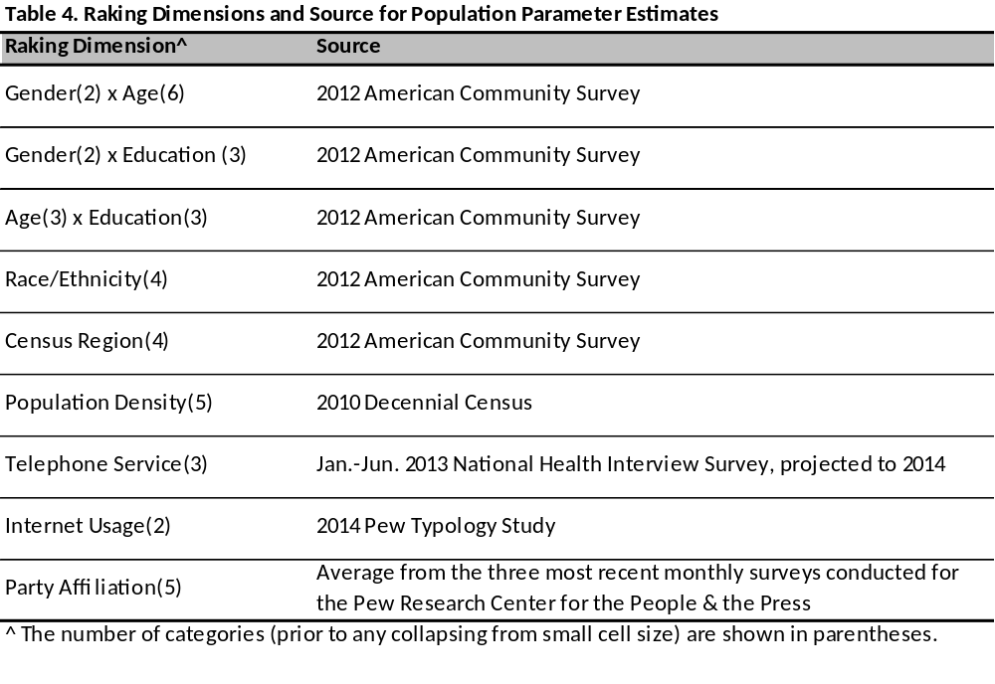

Most of the dimensions are commonly observed in weighting protocols for general population household surveys in the US. One exception is the raking for internet usage. This is included in the algorithm so that the panel survey estimates reflect the target population with respect to the proportion of people who use the internet and the proportion who do not. The large majority of ATP interviews are completed via self-administered Web survey. There is, therefore, a concern that internet users could be over-represented in the survey estimates if this dimension is not controlled for in the raking. Currently, the estimated population parameter for the percent of U.S. adults who use the internet is 88.6%, based on the 2014 Typology Survey conducted for the Pew Research Center. It would have been preferable to use a large, federal in-person survey (such as ACS or CPS) to obtain this parameter estimate, but unfortunately the federal government does not routinely measure internet access from any location.,
Trimming
The distribution of the raked weights was then evaluated and checked for extreme values. For the Wave 4 Study, the weights were trimmed at the 2nd and 98th percentiles.

VI. DESIGN EFFECT AND MARGIN OF ERROR
Weighting and survey design features that depart from simple random sampling tend to result in an increase in the variance of survey estimates. This increase, known as the design effect or deff, should be incorporated into the margin of error, standard errors, and tests of statistical significance. The overall design effect for a survey is commonly approximated as the 1 plus the squared coefficient of variation of the weights. For this survey, the margin of error (half-width of the 95% confidence interval) incorporating the design effect for full sample estimates at 50% is ±2.23 percentage points. Estimates based on subgroups will have larger margins of error. It is important to remember that random sampling error is only one possible source of error in a survey estimate. Other sources, such as question wording and reporting inaccuracy, may contribute additional error. A summary of the weights and their associated design effect is reported in Table 5 below.

Table 5. Design Effect and Effective Sample Size
Weight Variable | Completed Interviews | Approximate Design Effect | Effective Sample Size
WEIGHT_W4 | 3,217 | 1.66 | 1,943

VII. DISPOSITIONS
The final dispositions and AAPOR rates from the Web and mail components are reported in Tables 6a and 6b, respectively. The response rate to the Wave 4 Study itself was 60.9%. Table 7 reports the cumulative response rate for the Wave 4 Study when all of the stages of recruitment into the panel are taken into account.

Table 6a. Final Dispositions from the Web Component of the Wave 4 Study
Final Disposition | AAPOR Code | Cases
Completed interview | 1.10 | 2,849
Logged onto survey; broke-off | 2.12 | 44
Logged onto survey; did not complete any items | 2.1121 | 39
Never logged on (implicit refusal) | 2.11 | 1,797
Total Panelists in Web Sample of Wave 4 Study |  | 4,729
Completed interviews | I | 2,849
Partial interviews | P
Refusals | R | 1,880
Non-contact | NC
Other | O
Unknown household | UH
Unknown other | UO
Not eligible | NE
Total |  | 4,729
AAPOR RR1 = I / (I+P+R+NC+O+UH+UO) |  | 60.2%

Table 6b. Final Dispositions from the Mail Component of the Wave 4 Study
Final Disposition | AAPOR Code¹ |  |  |  |  |  | Cases
Completed mail survey during field period |  | 1.10 |  |  | 368
Completed mail survey after field period |  | 2.27 |  |  | 11
Refusal |  | 2.11 |  |  | 3
Other: Known eligible but nothing ever returned |  | 2.30 |  |  | 142
Other: Known eligible but undeliverable address |  | 2.30 |  |  | 32
Total Panelists in Mail Sample of Wave 4 Study |  |  |  |  |  |  |  | 556
Completed interviews |  |  | I |  |  | 368
Partial interviews |  |  | P
Refusals |  |  | R |  |  | 145
Non-contact |  |  | NC |  |  | 43
Other |  |  | O
Unknown household |  |  | UH
Unknown other |  |  | UO
Not eligible |  |  | NE
Total |  |  |  |  |  |  |  | 556
AAPOR RR1 = I / (I+P+R+NC+O+UH+UO) |  |  |  |  |  | 66.2 %
¹ These codes are modified for reflect the fact that this survey was a panel survey, not an RDD survey. All sample members were eligible.

Table 7. Cumulative Response Rate
Response Rate to Recruitment Survey | 10.6%
Percent of Recruitment Survey Respondents Who Agreed to Join the ATP, Among Those Invited | 54.4%
Response Rate to ATP Wave 4 Study | 60.9%
Cumulative Response Rate for the Wave 4 Study | 3.5%

The July 2011 Current Population Survey estimated that 73% of US residents age 15 and older access the internet from some location. Given the increasing trends in internet access, particularly on mobile devices, this 2011 CPS estimate was deemed too out-of-date to be helpful in the ATP weighting.
Starting in 2013 the American Community Survey is measuring internet access, but it only measures access inside the sample household. Members of the ATP are permitted to complete the surveys from any location. So the more relevant parameter for the ATP is the proportion of adults who can access the internet from any location, not just at home.

